Chapter 4, Problem 23.

Referring to Fig. 4.91, use source transformation to determine the current and power absorbed by the 8-Ω resistor.

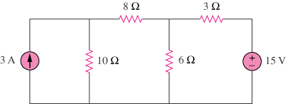

Figure 4.91
For Prob. 4.23.

